**Question 2**

**(b)** Negative correlation between fixed effect and average per capita income.

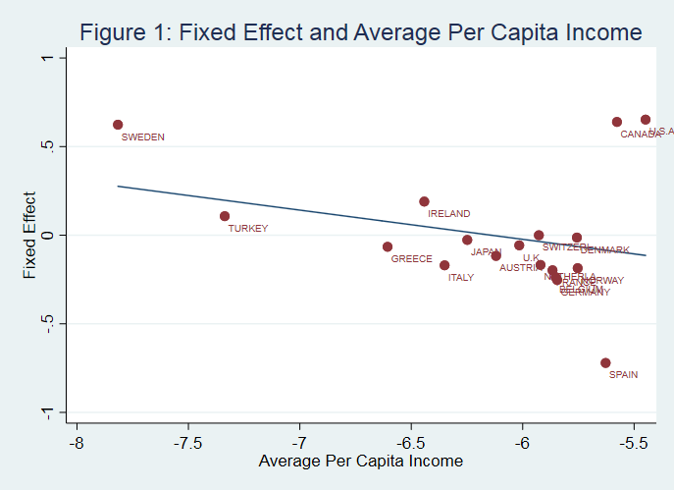

**(c)** Yes.

